# CS 340 README Animal Shelter

About the Project/Project Title

*This application of an animal shelter allows the user to access a database of animals in the CS 340 Austin Animal Center (aka AAC). The user is able to search and filter animals with the Grazioso Salvare dashboard who was the requester of the project. Additionally, extra features such as geolocation, user interaction, and charts allow the dashboard more versatility thus allowing the user to better search and rescue using the AAC.*

## Motivation

*The primary motivation for the project was to test my skill working with a database to manipulate that data as well as to create a user dashboard to display that data. The process of using Python to construct a CRUD that not only could work for manipulating the database but as allow for expanding the project into a dashboard showed that mongodb and Python together showed just how powerful the CRUD can be.*

## Getting Started

*In order to get the program started you first must:*

1. *Prepare the database by entering Mongo and importing the csv file called aac_shelter_outvome.csv*
2. *Create a simple and complex index for parsing the data inside the document.*
3. *Create both an Admin and aacuser account that has access to the database*
4. *A user with the ability to run/install python in order to run the script via a notebook*
5. *Connect to the dashboard via the link from the code.*

## Installation

*A version of python that is able to run both the .py and .ipynb files*

## Usage

*The usage of the dashboard is straight forward as seen in the screenshot section. You can choose from a list of filters via the radio buttons which will reduce the list of options for better searching. The list provided is designed to be user friendly and allows the user to both view the list and manage the charts and geolocation features. Whenever an animal is selected the dashboard automatically updates to provide details on the selected animal. The chart shows how many of each breed of animal exist within the filter which helps the user determine the correct filters to choose from. Additionally, the geolocation shows exactly where each animal is located, making it easy to locate a specific animal. Overall as seen from the screenshots below it is quite simple to navigate the interface as well as to filter results to help find animal within the AAC database.*

### Screenshots

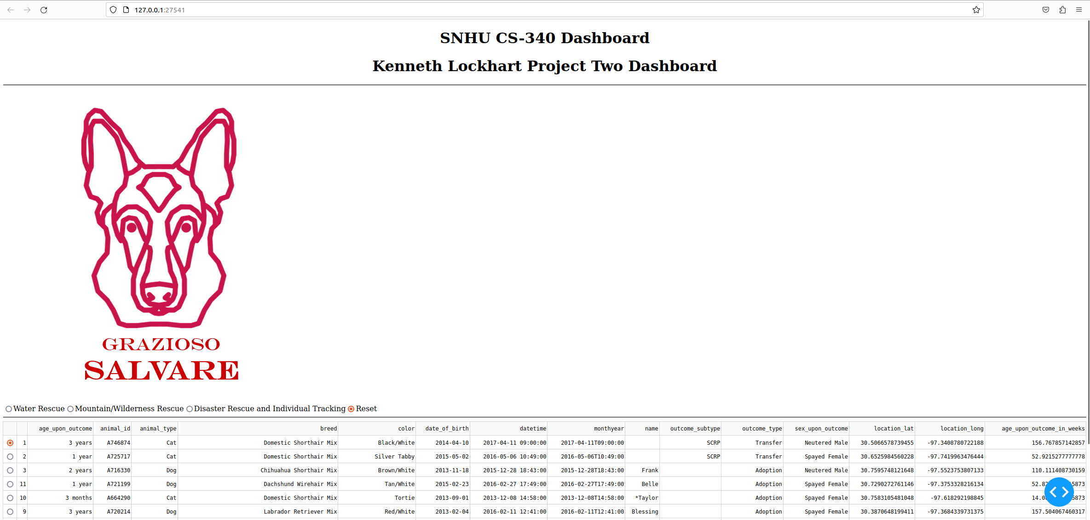

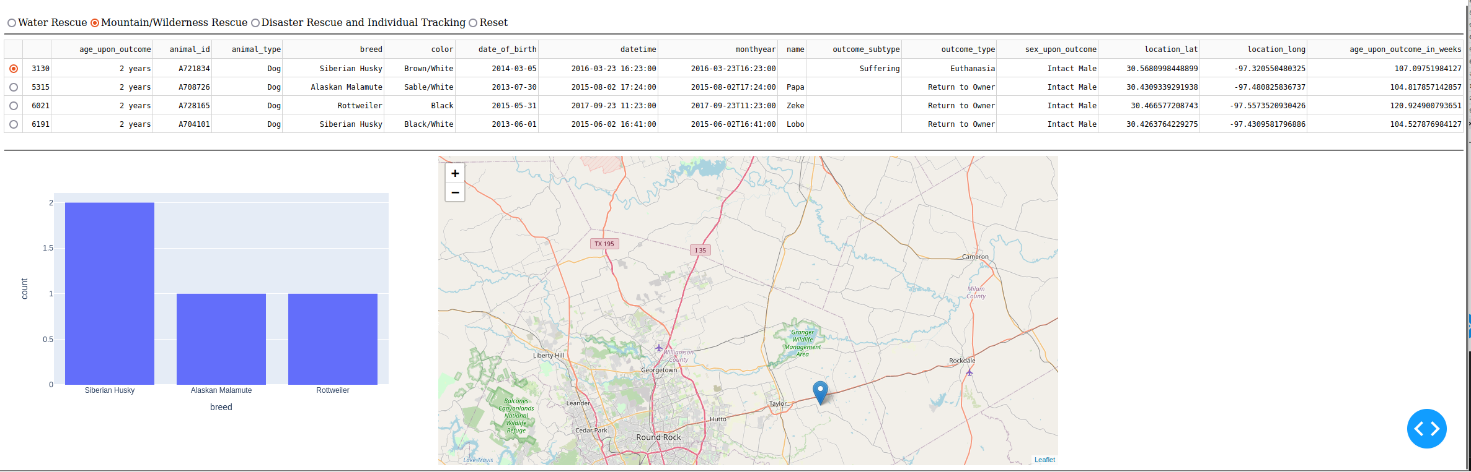

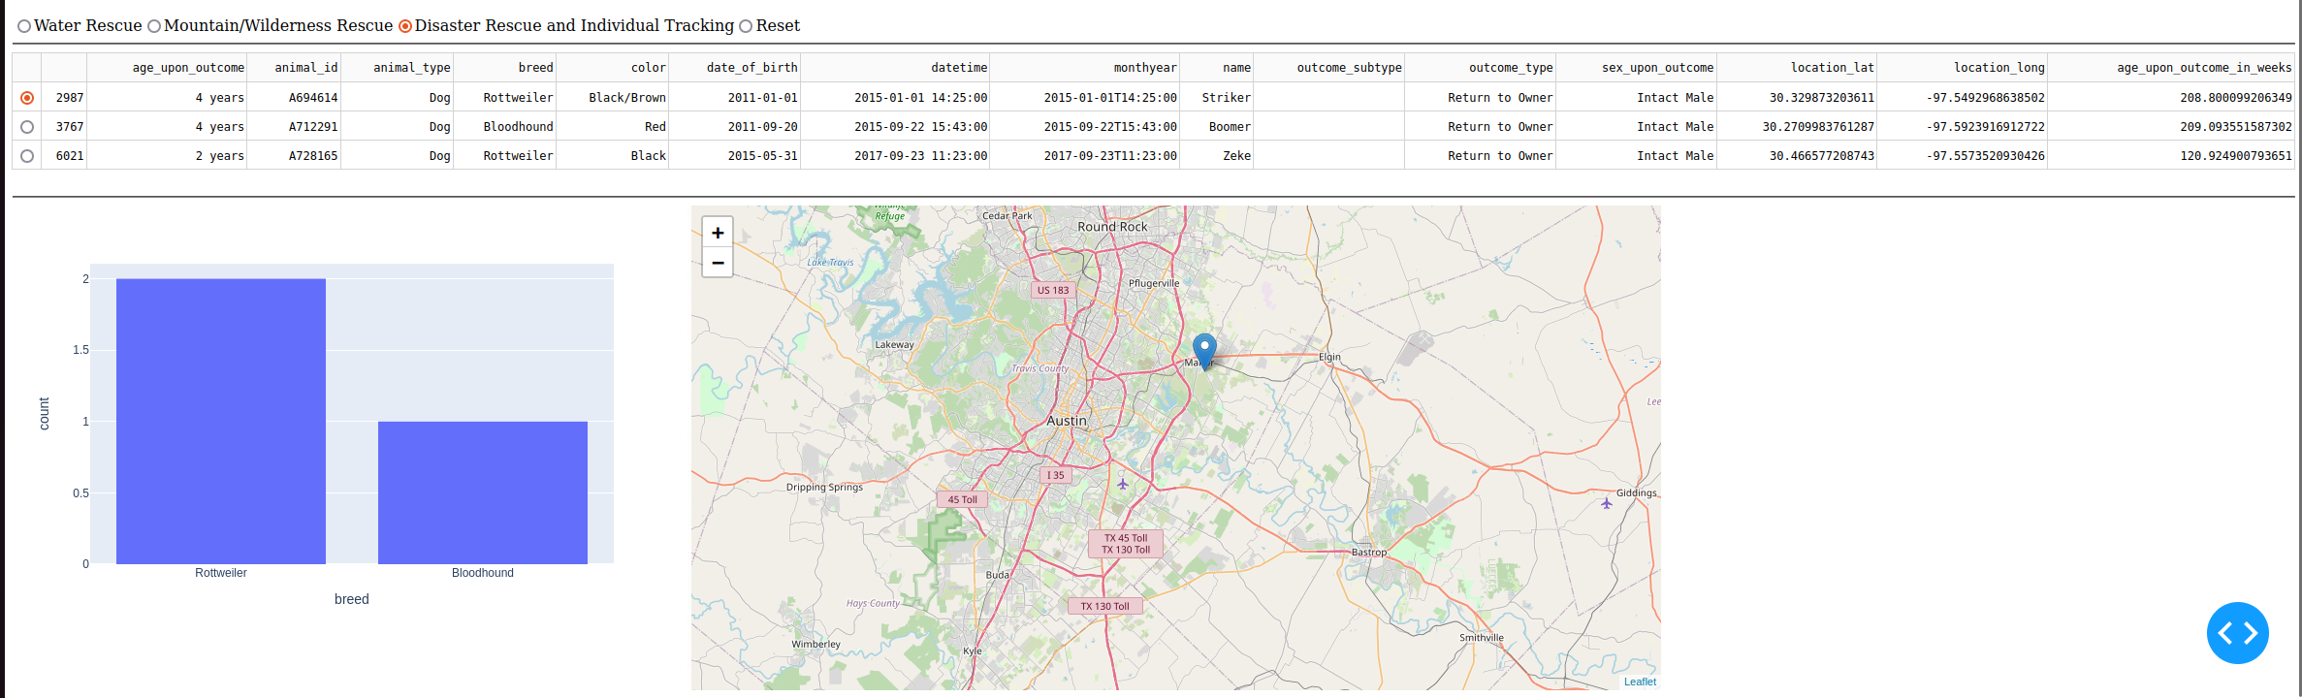

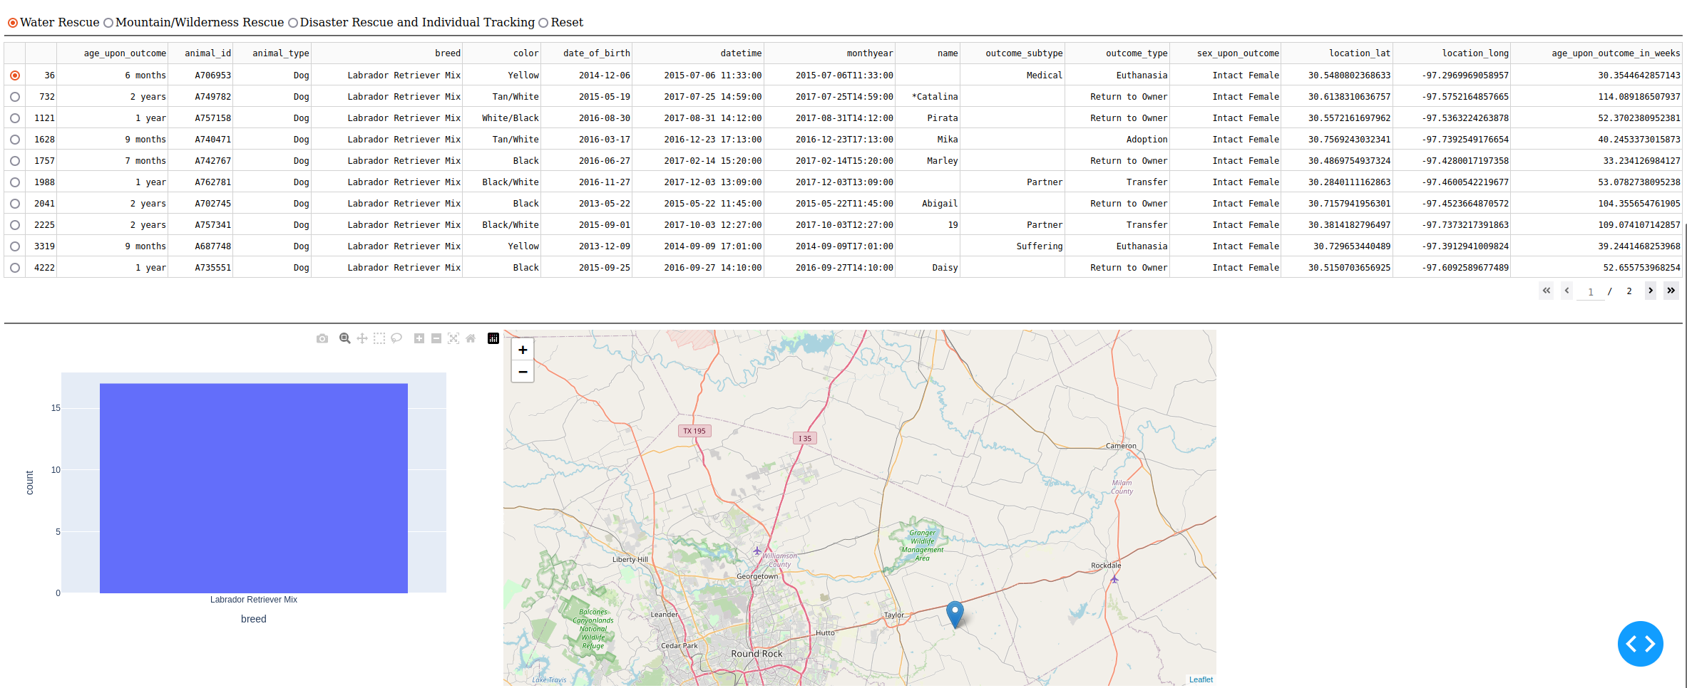

## Challenges

With this project there were very few challenges overall. The major challenge was handling all the errors as the message from the dashboard was less then help in understanding what was going on. Aside from that, understanding why the select rows did not fix said errors was another whole aspect of challenges that occurred. Overall, the project went smoothly, and it wasn’t horrible to track down these errors but it was time consuming.

## Contact

Kenneth Lockhart